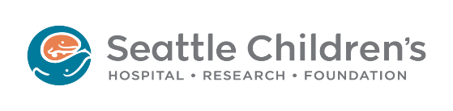
Institutional Review Board (IRB)
Consultation Request Form
Please see the information provided on the Seattle Children’s website about the Consultation Program [INSERT LINK to PAGE].
To request a consultation, take the following actions:

- Complete all sections of the form.
- Send it via e-mail to irb@seattlechildrens.org with the subject “CONSULTATION REQUEST.”

- Seattle Children’s Principal Investigator:
- Individual(s) who will participant in the consultation (include their e-mail addresses):

- Nature of Submission/Topic:
☐ Initial study (Click Study ID, if applicable):
☐ Modification (Click Study ID, if applicable):
☐ Other (explain):

- Funding (if applicable):

- Describe the reason for the consultation:

- Provide a brief description of the study and/or submission:
- For reliance consultations:
  - IRB that would review the study:
  - List of participating sites:
- Please briefly describe any issues/topic areas you would specifically like addressed during the consultation (use additional pages if necessary):

- Have you had a previous IRB consult/communication about this topic/submission?
☐ YES ☐ NO

  - If yes, person consulted and date of discussion:

