CHILDREN’S ONCOLOGY GROUP
AAML1831 Cardiac Studies Manual

A Phase 3 Randomized Trial for Patients with de novo AML Comparing Standard Therapy Including Gemtuzumab Ozogamicin (GO) to CPX-351 with GO, and the Addition of the FLT3 Inhibitor Gilteritinib for Patients with FLT3 Mutations

Table of Contents
1.0 INTRODUCTION 3
2.0 CARDIAC STUDIES PERSONNEL CONTACT INFORMATION 3
  - ECHOCARDIOGRAMS 4
  - Site Training & Site Echocardiogram Lab Certification 4
  - Echo Quality Review and Feedback 4
  - Echocardiogram Acquisition 5
  - Image Labeling, Transfer to DVD, and Shipment to Core Echo Lab 7
  - Shipping 7
  - Echocardiogram Timing 8
  - Contact Information 8
  - FAQ 8
4.0 ELECTROCARDIOGRAMS (ECGs) 10
4.1 Guidance Related to QTc Calculation 10
4.2 Timing of ECGs According to Arms 10
  - CARDIAC BIOMARKERS 12
  - Collection Time points 11
  - Collection, Processing, Labeling 12
  - Storage 13
  - Shipping 13
  - Contact Information 14
  - FAQ 14
6.0 References 14
APPENDIX 1 AAML1831 Transthoracic Echocardiography Acquisition Protocol 16
APPENDIX 2 AAML1831 Echo Acquisition Summary, Checklist & Submission Form 27
APPENDIX 3: AAML1831 Certification Sample Echocardiogram Submission Form 30

1.0 INTRODUCTION
This document is the Cardiac Studies Manual of Procedures for protocol AAML1831: A Phase 3 Randomized Trial for Patients with de novo AML Comparing Standard Therapy Including Gemtuzumab Ozogamicin (GO) to CPX-351 with GO, and the Addition of the FLT3 Inhibitor Gilteritinib for Patients with FLT3 Mutations. Submission of echocardiogram images and cardiac biomarkers is required for all patients enrolled on AAML1831.
The manual contains supplemental information regarding the cardiac correlative studies embedded within AAML1831. This manual is not a substitute for the protocol; rather it is intended to provide additional guidance on how to perform the required cardiac imaging and biomarker studies detailed in Section 18 of the protocol. If questions remain following review of the protocol and this manual, please contact the appropriate cardiac studies team contact as outlined below.
This manual has been prepared for the AAML1831 Cardiac Correlative Studies under the direction of Kasey Leger, MD at Seattle Children’s Hospital. Seattle Children’s Hospital will act as the coordinating center for the cardiac correlative studies. The Center for Quantitative Echocardiography at the University of Pennsylvania will serve as the core echocardiogram lab under the oversite of Bonnie Ky, MD, MSCE.

2.0 CARDIAC STUDIES PERSONNEL CONTACT INFORMATION
The AAML1831 study will utilize a central email for all communication regarding the cardiac studies. Questions/comments should be sent to: AAML1831cardiacstudies@seattlechildrens.org

AAML1831 Cardiac Studies PI Echocardiography Core Lab Proj. Manager
Kasey Leger, MD, MSC Laney Smith
Seattle Children’s Hospital Perelman School of Medicine at the
(206) 987-2106 University of Pennsylvania
Kasey.Leger@seattlechildrens.org (215) 615-3245
Amanda.Smith4@pennmedicine.upenn.edu

Echocardiography Core Lab PI Echocardiography Core Lab Sonographers
Bonnie Ky, MD, MSCE Jade Chung (Lead Sonographer for this study)
Perelman School of Medicine at the (215) 349- 5753
(215) 573-6606 Jade.Chung@pennmedicine.upenn.edu
bonnie.ky@pennmedicine.upenn.edu
Virginia Englefield

Pediatric Cardiology Virginia.Englefield@pennmedicine.upenn.edu
William Border, MD
Emory University Zhen Chen
Borderw@kidsheart.com zhen.chen@pennmedicine.upenn.edu

Ritu Sachdeva, MD
Emory University
Sachdevar@kidsheart.com

3.0 ECHOCARDIOGRAMS

Evaluation of cardiac toxicity in patients undergoing treatment for de novo AML is a major objective of AAML1831. Submission of echocardiogram images is required for all patients enrolled on AAML1831.

Echocardiogram evaluations reviewed at the central core echocardiogram lab will not be executed in real time and results will not be provided the patient’s treating physician. Echocardiograms obtained for AAML1831 must be evaluated by the treating institution’s personnel to make treatment decisions and dose modifications.

3.1 Site Training & Site Echocardiogram Lab Certification

High quality and standardized image acquisition is critical for the accurate assessment of cardiac function. Thus, AAML1831 will require documentation of echocardiogram site training. Each site’s PI and the appropriate study personnel are required to the cardiac studies specific training included in the general AAML1831 training slides and this Cardiac Studies Manual so that they are familiar with the required cardiac studies, the process of site echo lab training, and timing of echocardiogram submission.

Additionally, it is strongly encouraged that sites have a designated representative from cardiac imaging (i.e. Echo Lab) review the “AAML1831 Echocardiogram Acquisition Training” PowerPoint presentation and become familiar with the Echocardiogram Acquisition Protocol in Appendix 1 of this manual. The echo acquisition training slide deck will be available to download from the COG AAML1831 webpage. A recorded webinar is available to view: www.seattlechildrens.org/AAML1831cardiacstudies.

Furthermore, it is highly recommended that sites work with their echo lab to identify specific sonographer(s) who will perform echocardiogram acquisition for patients enrolled on AAML1831, whenever possible. Each sonographer will undergo a certification process and is encouraged to become familiar with and follow the acquisition protocol in order to capture the critical views necessary to measure the Biplane Simpson ejection fraction, strain, and additional measures of cardiac size and function. Sites will be responsible for ensuring that the cardiac imaging obtained meets the standards outlined in the protocol and cardiac studies manual.

3.2 Echo Quality Review and Feedback

Sonographer(s) from each site will undergo a certification process to ensure adequate echocardiogram quality. It is strongly preferred that sites identify specific sonographer(s) who will become familiar with the AAML1831 acquisition protocol and training materials and, whenever possible, perform all echocardiograms acquired for patients enrolled on AAML1831.

Sites have the option of submitting a sample echocardiogram prior to subject enrollment for each sonographer allocated to perform echocardiograms for AAML1831. This sample echo should meet the parameters outlined in the Echocardiogram Acquisition Protocol (Appendix 1) and can be submitted to the Core Echo Lab using the AAML1831 Certification Sample Echocardiogram Submission Form in Appendix 3. Alternatively, sites may attain sonographer certification with submission of required echocardiogram(s) for AAML1831 participants However, any DICOM echocardiogram images acquired by a sonographer prior to certification must be submitted to the Core Lab within 5 days of being obtained for a real time

assessment of echocardiogram image quality and required views. Images will be reviewed and feedback provided to the site sonographer/echo lab regarding image quality within 10 days of receipt. More than one round of echocardiogram reviews and feedback may be required before a sonographer becomes certified. This process will be repeated for each sonographer who will acquire echocardiograms for AAML1831.
Image quality “Needs Improvement”

Once a site receives notification of certification by the core lab to have acceptable and comprehensive echocardiogram quality, sites may ship echocardiograms acquired by certified sonographers at the end of each reporting period. Echocardiograms will be reviewed by the core lab at select time points for image quality and if necessary feedback will be provided to the site. If quality remains consistent, sites may not receive feedback on subsequent submissions. However, if echo quality is deemed unacceptable, feedback will be provided and the sonographer will transition back to real time submission for subsequent echocardiograms. If an echo needs to be acquired by a sonographer who has not been certified by the Core Lab, that echo must be submitted within 5 days of being obtained for review.

**Important: cardiac function will not be assessed in real time, thus measures of cardiac function, such as ejection fraction, will not be available to the sites for clinical decision making. **

Figure 1. Echo Submission & Sonographer Certification Flow Chart

“Acceptable” Imaging Quality

Subject enrolled, ECHO acquired by uncertified sonographer
CD/DVD sent to Core Echo Lab (within 5 days of acquisition)
CD/DVD quality reviewed by Core Echo Lab
Feedback provided to site and sonographer
(within 10 days of receipt)
Determination of Image Quality

Subsequent ECHO acquired (according to protocol specified timing)

Transition back to real-time submission if a different sonographer acquires echo or if image quality declines
Sonographer certified and approved for shipment of CD/DVDs at the end of each reporting period. Intermittent feedback provided, as needed

3.3 Echocardiogram Acquisition

Site echo labs should review and follow the AAML1831 Echocardiogram Acquisition Protocol in Appendix 1 of this manual. We ask that the performing sonographer complete the brief “AAML1831 Echo Acquisition Summary, Checklist & Submission Form” (see Appendix 2) during image acquisition and that the site CRA include the completed form with submission of the DICOM echo images. Key points related to the image acquisition process are provided here, however please see Appendix 1 for the full echocardiogram acquisition protocol.

    - Key Points:
- The most critical images are the 2D apical images in 4 chamber, 2 chamber, 3 chamber views and 2D parasternal short axis images, including individual loops at the LV apex, mid, and basal levels. These should be prioritized.

    - Please anonymize the study if possible. If the study is not able to be anonymized, this will be done at the core lab.
    - Label images with the Study Name (AAML1831), Study ID, patient initials (3-letter, with X if there is no middle name, Time Point (See Appendix 2 – e.g. Baseline, Induction), and Study Date.
    - Capture 2D, M-mode and Doppler images according to the AAML1831 Echocardiogram Acquisition Protocol in Appendix 1. Sites that perform 3-D echocardiography as part of their standard of care imaging have the option of capturing 3-D images as part of the AAML1831 Protocol.
    - Central review will not be performed in real time (aside from assessment of echo quality), thus central review measurements will not be used to guide dose modification. Decisions regarding anthracycline dose modification (according to Section 5.2 of the protocol) should be made based on the site measurement of ejection fraction (Biplane Simpson preferred).1 Dose modifications should not be made on shortening fraction unless ejection fraction is not evaluable.
    - Imaging should be performed on an available platform, consistent with either a GE E9, GE E95, or Philips EPIQ. GE is preferred, if available. Please try to use the same vendor throughout study duration at your site
    - The same certified sonographer(s) should acquire all images for participants throughout the trial
    - An adequate EKG tracing is required on all echocardiographic images
    - Include both the epicardium and endocardium in all images. This is more important than getting the highest possible frame rate.
    - Optimal sweep speed for Doppler and M mode is 100 mm/sec
    - Color Doppler scale is 40 to 80 cm/sec
    - All 2D images should be recorded with at least 3 beats per clip and at an acquisition frame rate of 40 to 90 frames/sec. If patient has sinus tachycardia, please record 5 beats per clip in the apical, short axis, and parasternal long axis views.
    - Two blood pressure measurements should be measured and recorded prior to the initiation of the echo exam. Please ensure proper BP cuff size and that patient has rested for 3-5 minutes prior to assessment.
    - In apical imaging planes, the maximum LV cavity lengths must be displayed and should be the same in all apical images. It is very important to avoid foreshortening of the ventricular cavities, especially of the left ventricle.

    - Image Labeling, Transfer to DVD, and Shipment to Core Echo Lab
Imaging should be performed on the same platform (e.g. GE or Philips) throughout the study, if possible. Sites are required to use echocardiographic machines that have a dedicated cardiac imaging package which should include Doppler imaging specifications for recording pulse wave and continuous wave spectral Doppler as well as tissue Doppler imaging. All images should be recorded in DICOM format and should be compatible with general DICOM analyzing programs. All images and cineloops are to be exported into DICOM format with “FULL FRAME RATE” (e.g. DICOM storage properties of maximum frame rate to be configured to “FULL” instead of “30”). If 3D images are obtained, we also need the Archive if on the GE or the raw data (acquisition frame rate) on the Philips.

Study should be anonymized if possible. If so, images should be labeled with COG Study ID, Subject Initials, Date of Echo and Time Point. If the study is not able to be anonymized, then this will be done at the core lab at the time of analyses. The actual DICOM DVD should be labeled using a Sharpie or permanent marker with the following:
AAML1831, COG Study ID
Subject Initials
Date of Echo
Time Point
As above in section 3.2, DICOM echocardiographic images should be sent within 5 days of being obtained prior to sonographer echo lab certification. Following sonographer certification for acceptable echocardiogram quality, sites may sendPlease submit all DICOM echo images obtained from certified sonographers at the end of each reporting period. All echocardiograms obtained during a given reporting period should be included (unless previously submitted to the core lab). Please note that each DVD should only include one time point for one patient.

    - Shipping
Login to Medidata Rave to complete the Cardiac Imaging STF and select the time point of echocardiographic DICOM images included in this shipment. Print and send the Cardiac Imaging STF along with the completed Echocardiogram Acquisition Form & Checklist (Appendix 2) and the original DVD via FedEx 2-Day mail to:

Penn Center for Quantitative Echocardiography Hospital of the University of Pennsylvania Rhoads Bldg., Ground Floor
3400 Spruce St.
Philadelphia, PA. 19104

Phone: +1 215 349-5753
Fax: +1 215 349-5859

COG sites may use the COG Federal Express account number per the COG policy available at: https://members.childrensoncologygroup.org/_files/reference/FEDEXmemo.pdf

  - Echocardiogram Timing

A summary of the required time points for echocardiogram acquisition are outlined below. Briefly, echocardiograms will be performed as standard of care at baseline, prior to every chemotherapy course, prior to allo-HSCT, before starting gilteritinib Maintenance, at week 26 of Maintenance, at the end of therapy, and if the patient relapses according to protocol Section
    - Additionally, echocardiograms will be performed during follow-up period according to the table in Section 7.4, including 1 year following completion of therapy and every 2 years thereafter, with increased frequency as clinically indicated in patients with identified abnormalities including even a transient decline in ejection fraction (EF) or shortening fraction (SF). Additional echocardiograms should be obtained as clinically indicated with symptoms of cardiac dysfunction. Refer to the AAAML1831 protocol for anthracycline dose modifications and additional guidance for abnormal cardiac function.
      - Baseline (Pre-Treatment)
      - Prior to Induction 2
      - Prior to Intensification 1
      - Prior to HSCT, may be performed as part of HSCT workup (if applicable)
      - Prior to Intensification 2 (if applicable)
      - Prior to Intensification 3 (if applicable)
      - Prior to initiation of Maintenance therapy with gilteritinib. (if applicable)
      - Week 25 of Maintenance (± 14 days). (if applicable)
      - End of therapy (within 30 days after the last dose)
      - If patient relapses echo should be performed prior to starting subsequent therapy
      - Year 1, 3, 5, 7, and 9 (± 30 days) after removal from or completion of protocol therapy. Patients may require more frequent monitoring if they have abnormalities in LV function or if the patient has a history of LVSD.

  - Contact Information
For questions regarding echocardiogram acquisition and/or submission please contact AAML1831CardiacStudies@seattlechildrens.org and the study team will respond accordingly.

  - FAQ

Who is the main contact regarding echo acquisition and submission?
Send your inquiry to AAML1831CardiacStudies@seattlechildrens.org. The study team will either address your question or escalate it to the appropriate party.

What training/guidance is provided on AAML1831 for acquiring quality echocardiograms?
PIs and delegates are encouraged to reference the Echocardiogram Acquisition & Cardiotoxicity Monitoring Training PowerPoint slide presentation with a high-level explanation. Additionally, site echo labs and sonographers should utilize the appendix in this Cardiac MOP for detailed instructions on quality echocardiogram acquisition and critical images necessary for the analyses planned on AAML1831.

My patient is due for an echocardiogram but is currently sick. Should we delay the echo?
If the patient is currently on protocol treatment the echocardiogram should be delayed until the patient has sufficiently recovered and is well enough to receive their next cycle of therapy. Please note that the echocardiogram must be collected PRIOR to the initiation of the subsequent cycle. Document the reason for the delay. Medical delays determined by the treating investigator(s) will not be considered a deviation.

If the patient is in the end of therapy phase, please wait until the patient has fully recovered. However, when possible the echocardiogram should be performed within 60 days from the start of the last cycle.

How will I know whether the sonographer who performed my patient’s echocardiogram is certified?
Each time a new sonographer acquires images for AAML1831 the Core Lab will send feedback via email to the primary CRC/CRA delegated to the study, as well as the sonographer and CRC/CRA listed on the Sonographer Checklist (see Appendix 2).Specimen Transmittal Form. This email will include determination of whether the quality of the submitted images is acceptable and meets criteria for sonographer certification.

- Which reporting period should the pre-cycle echocardiogram be reported in Cardiac Evaluations CRF? For example, should the pre-Induction 2 echocardiogram be reported in the Induction 1 Cardiac Evaluations CRF or Induction 2 CRF?
Please submit the pre-cycle echocardiogram data with the preceding reporting period. So in the above scenario, the pre-induction 2 echocardiogram should be reported on the Induction 1 reporting period cardiac evaluations CRF even if the pre-Induction 2 echocardiogram is obtained the same day as the start of Induction 2. If there are any questions, contact: AAML1831CardiacStudies@seattlechildrens.org.

My patient missed their time point for the echo. Should the echo be collected as soon as possible or reported as not done?
If the patient has not received the subsequent cycle of chemotherapy, please acquire and submit the echocardiogram as soon as possible. If the patient has already received the subsequent cycle of chemotherapy, the echocardiogram will be a missed and should be recorded as ‘not done.

Is de-identification of DICOM echocardiograms required prior to submission to the core lab?
Submission of de-identified DICOM images is strongly preferred, however not required. Echo image quality can be compromised during the process of study de-identification, so we suggest working with your Echo Lab to follow their standard process for study de-identification. Please contact the AAML1831 Cardiac Studies Team, with any questions about this process, at AAML1831CardiacStudies@seattlechildrens.org.

Do you provide disks or shipping supplies?
Blank DVDs and shipping supplies are not provided.

ELECTROCARDIOGRAMS (ECGs)

ECGs are required to monitor for QTc prolongation and/or other rhythm disturbances throughout AML therapy. These are of particular importance in patients who are receiving gilteritinib (Arms AC/ BC and Arms AD / BD) given that gilteritinib has been associated with increased risk for QTc prolongation. Therefore, more intensive ECG monitoring is required for patients treated on the gilteritinib containing arms (see specific time points below). Please refer to the AAML1831 protocol for gilteritinib dose modification guidance.

4.1 Guidance related to QTc calculation

There are various methods for calculating the QTc interval and the standard method used at each pediatric institution may vary. The Fridericia formula (QTcF) is the preferred method for QTc correction in adults and that recommended for drug toxicity monitoring by the FDA and the package insert for gilteritinib. The Bazett formula (QTcB) is more commonly used in pediatric populations since it provides the most consistent correction across a wide range of high heart rates. Thus, QTcB is the standard method for QTc correction in many pediatric institutions.² However, the Bazett correction formula appears to overestimate the prevalence of prolonged QTc, particularly in the older pediatric population.^{3,4} Thus, in order to avoid unnecessary withholding of gilteritinib, all dose modifications of gilteritinib should be based on QTc correction using the Fridericia formula. While it is acceptable to rely on the Bazett formula (QTcB) as the default screen for QTc prolongation, borderline or prolonged measurements for patients on Arms C/D should be confirmed using the Fridericia formula (QTcF).
Formulas for QTc calculation:
- QTcF (Fridericia) = QT/RR^(1/3) – preferred method
- QTcB (Bazett) = QT/RR^(1/2)

The QT and RR intervals are typically generated by the ECG machine and should be readily available for above calculations. The RR can also be calculated using the heart rate (or “ventricular rate”) on ECG report: RR = 60/HR

**Note: QTc calculation using the standard institutional method is acceptable as a screen for QTc prolongation. However, if QTc ≥ 480 ms or > 30 ms higher than baseline, QTcF must be calculated and gilteritinib dose modifications should only be made for QT prolongation confirmed using the Fridericia formula (QTcF)**

4.2 Timing of ECGs according to Arm:
ECGs are required at the following time points on Arms A/B:

Baseline/ Pre-Treatment
    - Induction 2 (Up to 14 days prior)
    - Intensification 1 (Up to 14 days prior)
    - Intensification 2 (Up to 14 days prior)
    - Intensification 3 (Up to 14 days prior)

End of therapy
    - Relapse, if applicable

ECGs are required at the following time points on Arms AC/ BC/ AD/ BD:

Baseline/ Pre-Treatment
    - Induction 1, Day 8* (prior to gilteritinib dosing)
    - Induction 1, Day 18† (Day 8 of gilteritinib: prior to gilteritinib dosing)
    - Induction 1, Day 25† (Day 15 of gilteritinib: prior to gilteritinib dosing and 4-6 hours after dosing to coincide with Day 25 PK)
    - Induction 2 (Up to 14 days prior)
    - Induction 2, Day 11^ (Prior to gilteritinib dosing)
    - Intensification 1 (Up to 14 days prior)
    - Intensification 1, Day 6^ (Prior to gilteritinib dosing)
    - Intensification 2^ (Up to 14 days prior)
    - Intensification 3^ (Up to 14 days prior)
    - Prior to the start of Maintenance^ (Up to 14 days prior)
    - Every 12 weeks during Maintenance (± 1 week)

End of therapy
    - Relapse, if applicable

*In order to start gilteritinib-containing regimens, QTc needs to be less than 480 ms and less than 30 ms greater than baseline. If the Day 8 ECG shows a QTc that is >480 ms or >30 ms higher than the ECG done prior to beginning Induction 1, calculate QTcF (Fridericia, see guidance above for QTc calculation). If QTcF is > 480 ms or > 30 ms higher than baseline QTcF, obtain repeat ECGs daily until QTcF has returned to a range of < 30 ms from baseline or < 480 ms in order to remain eligible for gilteritinib-containing arms (AC/AD or BC/BD). Note: gilteritinib dose modifications should only be made for QT prolongation confirmed using the Fridericia formula (QTcF). Efforts should be made to correct any electrolyte abnormalities and/or remove any agents known to prolong QT interval. Please refer to the AAML1831 protocol for gilteritinib dose modification guidance.

† Adjust the day of the ECGs accordingly if patient started taking gilteritinib later than Day 11.

^ If the QTc interval is > 30 ms higher than the ECG done on Day 8 of Induction 1, additional ECG monitoring may be done per physician preference.

5.0 CARDIAC BIOMARKERS
Evaluation of cardiac toxicity in patients undergoing treatment for de novo AML is a major objective of AAML1831. Submission of cardiac biomarkers is required for all patients enrolled on AAML1831.

Specimen collection and shipping supplies are not provided by the Leukemia Biospecimen Bank (or the Biopathology Center). Institutions are responsible for providing their own collection and shipping supplies.

  - Collection Time points
**Please note, not all patients will have all samples drawn.

Baseline/ Pre-Treatment
    - Induction 1, Day 8 (± 2 days)
    - End of Induction 1 (± 7 days, must be drawn before start of Induction 2 systemic therapy)
    - End of Induction 2 (± 7 days, must be drawn before start of Intensification 1 systemic therapy)
    - End of Intensification 1 (± 7 days, must be drawn before start of Intensification 2 systemic therapy or prior to patient beginning preparative regimen for HSCT)
    - Intensification 2, Day 8 (± 2 days) only in those receiving Mitox/AraC (patients assigned to LR2)
    - End of Intensification 2 (± 7 days, must be drawn before start of Intensification 3)
    - End of Intensification 3 (± 7 days)
    - Prior to the start of Maintenance For patients who received HSCT and are getting Mmaintenance, the sample may be drawn up to 1 week prior to the start of Maintenance. For patients who are chemotherapy only and will be receiving Maintenance, the sample at the end of Intensification 3 will serve as the pre-Maintenance sample.
    - Week 26 of Maintenance (± 14 days)
    - End of Therapy (± 7 days. The end of Intensification 2 or 3 can serve as the end of therapy sample if that is the last course of therapy for that patient.)

Samples may be drawn in conjunction with the end of course bone marrow. These samples do not depend on count recovery and do not need to be repeated if drawn prior to count recovery.

  - Collection, Processing, Labeling

Collect two 5mL tubes of peripheral blood
    - 1 x 5 mL purple top (EDTA)
    - 1 x 5 mL green top (Lithium heparin)

(For infants and smaller participants: If blood volume obtainable is limited at any timepoint, please collect as much as possible and split it between the two tube types.)
Gently invert tubes 5 – 10 times to mix the blood and anticoagulant. Place on wet ice.
Process within 2 hours of collection
    - Spin in refrigerated (4°C) centrifuge at 2500g for 10 minutes
    - Using sterile pipettes, transfer 0.5-1mL plasma aliquots into 1-2mL cryovials
Label each cryovial with the following information:
- Study number (AAML1831)
- COG patient ID
- BPC number
- Date and time of collection
- Date and time of processing
- Time point (please include treatment course and course timing, i.e. pre-course, Day 8, or end of course)
- Specimen type: EDTA plasma or heparin plasma

  - Storage
Store processed specimens at -20°C for up to 3 days, or indefinitely at -80°C until shipped.

  - Shipping

Cardiac biospecimens may be shipped immediately after processing (Monday-Thursday) or stored and shipped at the end of each reporting period. Include a copy of the AAML1831 Cardiac Biomarker Specimen Transmittal Form (available in RAVE). One specimen transmittal form should be used for each patient. If sending more than 1 patient’s specimen, please separate each patient’s specimens into separate bags, including the Specimen Transmittal Form. All bags can be placed into the same box.

Specimens must be shipped according to IATA guidelines (www.iata.org). Place specimens inside a leak proof biohazard bag with absorbent material and a pressure resistance Tyvek envelop. Place packaged specimens in an insulated shipping container with at least 5 lbs. of dry ice. Complete a dry ice label (UN 1845) and place the dry ice label and an Exempt Human Specimen label on the side of the shipping container. Place a FedEx shipping label on the top of the shipping container.

Frozen samples may only be shipped on Monday through Thursday for a Tuesday through Friday delivery. NO SATURDAY DELIVERY

Samples should be mailed by FedEx Priority Overnight. COG sites may use the COG Federal Express account number per the COG policy available at: https://members.childrensoncologygroup.org/_files/reference/FEDEXmemo.pdf

Ship to the following address: COG Leukemia Biospecimen Bank Nationwide Children’s Hospital
700 Children’s Drive, Room C0825 Columbus, OH 43205
Phone: (614)722-2866
Fax: (614)722-2856
Email: MGLab@nationwidechildrens.org

Samples will be stored at the COG Biorepository and transferred to the Cleveland Clinic and the Center for Cardiovascular Diagnostics and Prevention. Dr. Wilson Tang will perform the biomarker assays.

If patient/parent/responsible party consents, any specimens left over on this study after required tests are performed will be banked for future research studies at the COG Leukemia Biospecimen Bank.

  - Contact Information

For questions regarding cardiac biospecimen acquisition and/or submission please contact AAML1831CardiacStudies@seattlechildrens.org and the study team will respond accordingly.

  - FAQ

- Who is the main contact regarding cardiac biospecimen acquisition and submission? Send your inquiry to AAML1831CardiacStudies@seattlechildrens.org. The study team will either address your question or escalate it to the appropriate party.

My patient missed a time point. Should I draw it now?
If the patient has not yet proceeded to their subsequent therapy cycle, it is likely still acceptable to collect and submit the biospecimens. Please send an inquiry to AAML1831CardiacStudies@seattlechildrens.org explaining the situation and the study team will determine if it is appropriate to collect out of window. However, if the patient has already started the subsequent chemotherapy cycle, the sample should not be collected.

My patient is due for a blood draw but is currently admitted for an infection or other illness. Should I draw the biospecimen now or wait?
The mid-cycle (Day 8) blood draws should be drawn within window regardless of systemic illness. However, the end of cycle blood draws for cardiac biomarker analysis may be delayed if the patient has significant illness (i.e. active infection, severe anemia, hypotension, etc.). When possible these samples should be collected when the patient has sufficiently recovered from the toxic effects of the current cycle and is nearly ready to proceed to the subsequent cycle. However, it is preferable for the sample to be collected before the patient is fully recovered than for the blood draw to be missed. Please note that the biospecimens should be collected PRIOR to the initiation of the subsequent cycle.

Do you provide tubes or shipping supplies?
Specimen collection and shipping supplies are not provided by the Leukemia Biospecimen Bank (or the Biopathology Center). Institutions are responsible for providing their own collection and shipping supplies. Sites may utilize the COG FedEx account number per the COG policy.

What if a specimen time point was missed/ not collected? Should I still collect subsequent specimens?
Yes, please! Every biomarker specimen is critical for the success of this analysis. Even if a patient’s specimen was missed at a specific time point, please continue to collect and send specimens for all subsequent time points as outlined in the Cardiac MOP and protocol. The biomarker assays are not dependent on other time points.

References

    - Plana JC, Galderisi M, Barac A, et al: Expert consensus for multimodality imaging evaluation of adult patients during and after cancer therapy: a report from the American Society of Echocardiography and the European Association of Cardiovascular Imaging. J Am Soc Echocardiogr 27:911-39, 2014
    - Phan, D.Q., et al., Comparison of formulas for calculation of the corrected QT interval in infants and young children. J Pediatr, 2015. 166(4): p. 960-4 e1-2
    - Prasad, S., et al., Baseline values from the electrocardiograms of children and adolescents with ADHD. Child Adolesc Psychiatry Ment Health, 2007. 1(1): p. 11
    - Muluneh, B., et al., Trials and Tribulations of Corrected QT Interval Monitoring in Oncology: Rationale for a Practice-Changing Standardized Approach. J Clin Oncol, 2019. 37(30): p. 2719-2721.

APPENDIX 1: AAML1831 Transthoracic Echocardiography Acquisition Protocol

Appendix Contents:
- Appendix 1: Detailed Echo Acquisition protocol
  - General notes & important considerations
  - Detailed data acquisition
- Appendix 2: Echo Acquisition Summary, Checklist & Submission Form
- Appendix 3: Sample Echocardiogram Submission Form (for certification only)

General notes & important considerations:

- Please refer to the AAML1831 Echo Acquisition Summary, Checklist, & Submission Form below (Appendix 2) when performing echocardiograms for this trial. Appendix 2 should be submitted along with each DICOM study.
- The most critical images are the 2D apical images in 4 chamber, 2 chamber and 3 chamber views. These should be prioritized.
- Anonymize the study if possible and please ensure the images contain the Study Name (AAML1831), Study ID, patient initials (3-letter, with X if there is no middle name, Time Point (See Appendix 2 – e.g. Baseline, Induction), and Study Date. If the study is not able to be anonymized, this will be done at the core lab.
- Two BP measurements should be measured and recorded prior to the initiation of the echo exam as per standard clinical practice. Please ensure proper BP cuff size and that patient has rested for 3-5 minutes prior to assessment.
- For 2D acquisitions, record at least 3 beats per clip. If the patient’s heart rate is over 100, record 5 beats per clip in the apical, short axis, and parasternal long axis views. .
- An adequate EKG tracing is required on all echocardiographic images.
- Extra 2-D gain is indicated for quantitative analysis of two-dimensional images. It is preferable to overgain rather than to undergain.
- It is critical to include both the epicardium and endocardium in all images, throughout systole and diastole.
- In apical imaging planes, the maximum cavity lengths must be displayed and should be the same in all apical images. It is very important to avoid foreshortening of the cavities, especially the left ventricle.
- For apical images, acquisitions focusing on the LV should not include the left atrium (LA). The depth should, therefore, be adjusted accordingly. The left atrium will be acquired separately in a dedicated acquisition. This will allow maximization of spatial resolution and frame rates for offline analyses focused on the LV and LA, respectively.
- The LV apex images can be performed apex-down according to lab convention.
- For 2D apical acquisitions, do not narrow the sector angle excessively for two-dimensional imaging because this crops the LV apical segments. The figure below shows examples of mild cropping, severe cropping and adequately acquired 2D images for LV assessment from the apical views. Again, please include both the endo and epicardium.

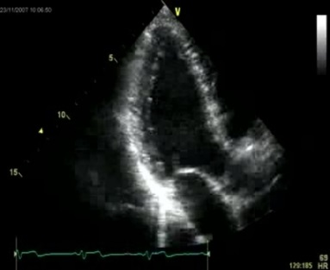
Adequate image o PSAX LV papillary muscle level w/o cropping
Adequate 3-chamber image
w/o cropping
- For short axis images, please try to have images in alignment with the beam and rounded short axis
- Parasternal short axis views at the base, mid-ventricle and apical planes may be used for speckle tracking (and assessment of myocardial strain). Similarly, apical 2-chamber, 4-chamber, RV apical and 3-chamber views may be used for strain analyses. We require images at specific frame rates (40-90 frames/sec) for post hoc analyses.
- For high quality LV apical images, please include as part of the LV the mitral annulus and a small part of the LA are needed in the apical 4-chamber, apical 3-chamber and apical 2-chamber.
- High quality short axis views of the LV should be obtained at the level of the LV apex, papillary muscles and mitral valve at basal level.
- Maximize the size of the pulsed and continuous Doppler spectral velocity tracings by adjusting the scale and using the baseline shift function. Optimize the reject and gain to provide thin and clearly defined spectral envelopes. Minimal gain should be employed. Use of excessive wall filtering should be avoided.
- Imaging should be performed on the same platform (e.g. GE or Philips) throughout the study, if possible. Sites are required to use echocardiographic machines that have a dedicated cardiac imaging package which should include Doppler imaging specifications for recording pulse wave and continuous wave spectral Doppler as well as tissue Doppler imaging.
- All images should be recorded in DICOM format and should be compatible with general DICOM analyzing programs. All images and cineloops are to be exported into DICOM format with “FULL FRAME RATE” (e.g. DICOM storage properties of maximum frame rate to be configured to “FULL” instead of “30”).
- After completion, please make two (2) copies of the echo directly from the machine in DICOM format at acquisition frame rate. If you recorded 3D images and are using a GE machine, please also make two (2) Archive copies.

Detailed Data Acquisition
Echocardiographic examinations performed for this study must include but need not be limited to the following:

- Subcostal Views:
  - From a subcostal 4-chamber view, the scan plane is angled to the patient's right to image the inferior vena cava, and this is recorded through several respiratory cycles. This is in the long-axis plane of the abdomen.
  - Continuous wave Doppler of the maximum TR velocity can be obtained.
  - The inferior vena cava is imaged through multiple respiratory cycles and the RAP estimated from visual assessment of the inferior vena cava. Capture 5 seconds in this view of the IVC with and without sniffing.

- Apical 4-Chamber View:
  - 2D imaging and overview of the LV and LA is performed. The entire left atrium is displayed. Acquisition should clearly delineate the endocardial border.
  - 2D imaging focused on the LV at decreased depth (include annulus and small amount of LA).
  - 2D zoomed image of the LA is obtained.
  - Pulsed wave Doppler of the LV inflow tract (LVIT) is recorded with the sample volume at the MV leaflet tips.
  - Color flow Doppler of the mitral valve, including the left atrium, is performed to interrogate for mitral regurgitation.
  - Continuous wave Doppler across the mitral valve to assess LV inflow and MR is also recorded.
  - Pulsed wave Doppler of one of the two upper pulmonary veins is obtained by placing a sample volume in the pulmonary vein.
  - The spectral signals of pulsed wave tissue Doppler imaging (TDI) with the sample volume positioned at the base adjacent to the interventricular septum, the LV lateral wall and RV free wall are obtained.
  - The transducer is repositioned to optimize the RV and RA and 2-D images are recorded. RV cavity areas and dimensions are measured in diastole and systole. Color flow Doppler of tricuspid regurgitant flow, if any, is obtained, and continuous wave Doppler signal of tricuspid regurgitation is recorded. Pulsed wave Doppler of the RV inflow tract is recorded with the sample volume at the TV leaflet tips.
  - The M-mode cursor is directed through the tricuspid annulus and the M-mode recorded at a sweep speed of 100 mm/sec. Tricuspid annular plane systolic excursion (TAPSE) will be measured.

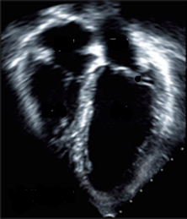

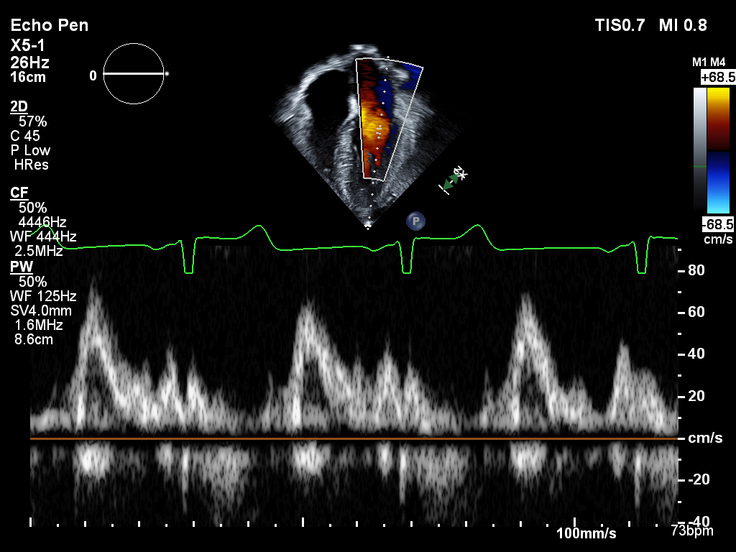

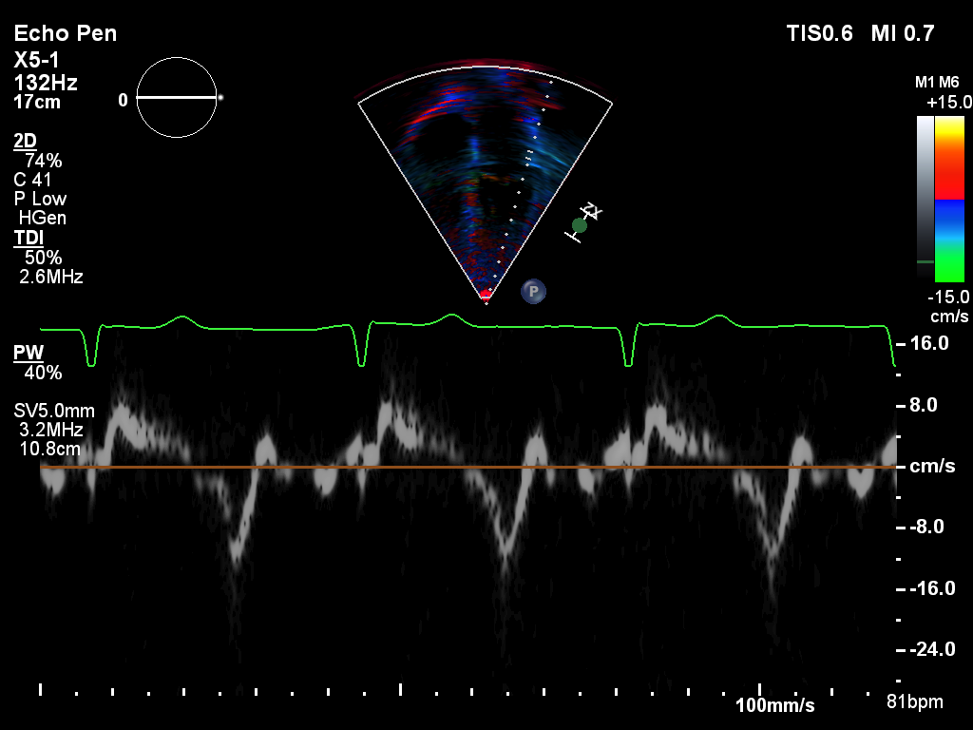

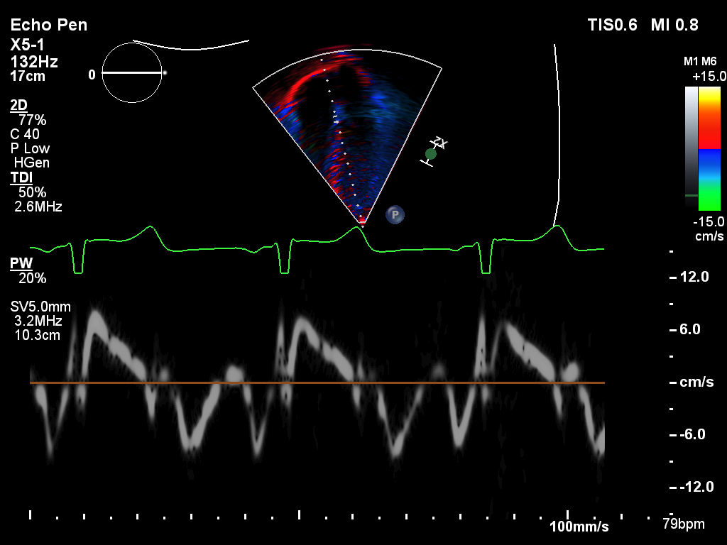

- Apical 5-Chamber View:
  - The imaging plane is adjusted to obtain an apical 5-chamber view. 2D images of the AV/LVOT as well as LV and LA are obtained.
  - Color flow Doppler of the aortic valve is used to interrogate for aortic insufficiency (AI).
  - Continuous wave Doppler across the aortic valve to assess LV outflow and AI is also recorded.
  - The PW sample volume is positioned in the LVOT approximately 0.5 cm proximal to the aortic valve leaflets and the spectral pulsed wave Doppler signal is recorded. The LVOT flow velocity integral will be measured. See first Doppler image below.
  - The PW sample volume is positioned between the aortic and mitral valves to assess simultaneously the MV inflow and LVOT flow to measure the IVRT (isovolumic relaxation time) and IVCT (isovolumic contraction time) See second Doppler below.

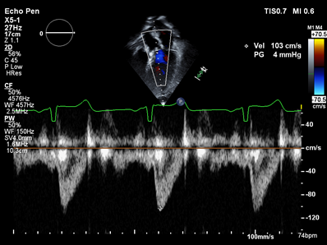

PW Doppler of simultaneous MV inflow and LVOT flow for IVRT and IVCT

- Apical 2-Chamber View:
  - The imaging plane is adjusted to obtain an apical 2-chamber view. 2D imaging and overview of the LV and LA is performed. The entire left atrium is displayed. Acquisition should clearly delineate the endocardial border.
  - 2D imaging focused on the LV at decreased depth (include annulus and small amount of LA).
  - 2D zoomed image of the LA is obtained.
  - Color flow Doppler of the mitral valve, including the left atrium, is performed to interrogate for mitral regurgitation.

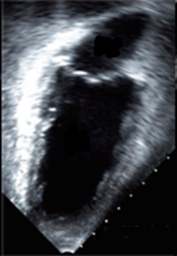
- Apical Long Axis (3-Chamber) View:
  - The imaging plane is adjusted to obtain an apical 3-chamber view.
  - 2D imaging and overview of LV and LA is performed. Acquisition should clearly delineate the endocardial border.
  - 2D imaging focused on the LV at decreased depth (include annulus and small amount of LA).
  - Color flow Doppler of the aortic valve is performed to interrogate for aortic insufficiency.

- Parasternal Long Axis View:
  - Images are recorded and color Doppler interrogation of the left ventricle, left atrium, mitral valve, aortic valve, and left ventricular outflow tract is performed.
  - Zoomed images of the left atrial size and left ventricular outflow tract (LVOT) diameter are obtained.
  - Color Doppler of the mitral valve for mitral regurgitation (MR) and LVOT for aortic insufficiency is performed.

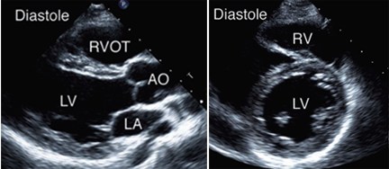

- Parasternal Short Axis View:
  - 2D images of the LV in short axis are obtained at the base, mid and apical levels.
  - 2D images and color Doppler of the aortic valve (AV) are obtained.
  - 2D images, pulsed and continuous wave, and color Doppler of the pulmonic valve (PV) are obtained.
  - 2D images, continuous wave, and color Doppler of the tricuspid valve (TV) are obtained.

- Right Ventricular Inflow Tract:
  - 2D images are obtained.
  - A careful color Doppler assessment of tricuspid regurgitation (TR) is performed.
  - If the color signal of TR is identified, continuous wave Doppler is recorded.

- 3D Acquisition of the LV (Optional): Sites that are performing 3D imaging as part of their routine echocardiogram have the option of recording 3D images for AAML1831. Images must be at least 25 frames per second.
  - Image of LV only
  - Image of LV and LA
  - Image of RV only
  - Image of RV and RA

APPENDIX 2 AAML1831 Echo Acquisition Summary, Checklist & Submission Form (Please send pages 1-3 with STF and DVD)

CRC should complete Section 1 of this form for each study echocardiogram and then give the form to the sonographer who will perform the echocardiogram. After the echocardiogram is complete and copied onto DVD, the form should be kept with the DVD and submitted to the Echo Core Lab. A copy should be retained in the patient’s research chart.

SECTION 1: (Completed by CRC)

COG Patient ID & Initials:
Date: | Height: | Weight:
Timepoint: | - Baseline (pre-treatment)  - Prior to Induction 2  - Prior to Intensification 1  - Prior to HSCT  - Prior to Intensification 2  - Prior to Intensification 3  - Prior to initiation of Maintenance Gilteritinib  - Week 25 of Maintenance  - End of therapy  - Year 1 after end of therapy  - Year 3 after end of therapy  - Year 5 after end of therapy  - Year 7 after end of therapy  - Year 9 after end of therapy  - Other (please specify): _______________
CRC NAME
CRC EMAIL
SITE NAME

SHIP TO: Penn Center for Quantitative Echocardiography
Hospital of the University of Pennsylvania
Rhoads Bldg., Ground Floor
3400 Spruce St.
Philadelphia, PA. 19104
Phone: 215 349-5753

You may use the COG FEDEx account number per the COG policy available at: https://members.childrensoncologygroup.org/_files/reference/FEDEXmemo.pdf

SECTION 2: Sonographer Checklist (Completed by Sonographer)
This patient is enrolled on AAML1831. Please use the below checklist as a reference to ensure all required images are recorded. Thank you for your support of this important study!

Sonographer Name
Sonographer Email
Requesting certification? | ☐YES ☐NO

PLEASE REMEMBER:
- Two blood pressure measurements should be recorded prior to starting the echo exam. Ensure proper BP cuff size and patient has rested for 3-5 minutes. Record each below.
- Record at least 3 beats per clip. If heart rate is ≥ 100 bpm, then at least 5 beats.
- Include the epicardium and endocardium in all images, throughout systole and diastole.
- Avoid foreshortening of the cavities.
- If possible, Doppler and TDI should be acquired at 100mm/s sweep speed.
- Record images at 40-90 frames per second.
- 3D imaging may be acquired if your site performs it routinely.

After the echo is complete:
- Anonymize if possible. If so, images should be labeled with COG Patient ID, Subject Initials, Time point and Date of Echo.
- Make two (2) copies of the echo directly from the machine in DICOM format at acquisition frame rate. One (1) copy should be stored at site and one (1) copy should be sent to the core lab for review.
  - If you recorded 3D images and are using a GE machine, please also make two (2) ARCHIVE copies, or of the RAW DATA (acquisition frame rate) if using a Philips.
- DVDs should be labeled using a marker with: AAML1831, COG Patient ID (found on the top of this form), Subject Initials, Date of Echo, and Time Point (as per Appendix 2, Section 1).
- Give the DVDs and this form to the coordinator to submit to the Core Lab
Please contact AAML1831CardiacStudies@seattlechildrens.org with any questions.

1st SBP | ____________mmHg |  | 2nd SBP | ____________mmHg
1st DBP | ____________mmHg |  | 2nd DBP | ____________mmHg
Note: It is acceptable to scan out of the order below, if preferred based on your lab’s standard protocol. However, please prioritize the critical images outline below and consider obtaining these first in the case of a difficult exam.

Critical Images are bolded and italicized below & include:
- 2D LV images in the apical 4C, 2C, and 3C views
- Parasternal short axis, including individual images at the LV apex, mid, and basal levels
SUBCOSTAL IMAGING WINDOW
 |  | Visualize the IVC and record continuously for several respiratory cycles w/ and w/o sniff for an estimate of RA pressure (5 sec acquisition)
APICAL IMAGING WINDOW
Apical Four-Chamber View |  | 2D overview of LV and LA (maximize LV and LA lengths)
 |  | 2D imaging focused on LV (annulus and small part of LA)
 |  | 2D imaging focused/zoomed on LA
 |  | Color Doppler of MV/LA for MR
 |  | CW Doppler of LV Inflow and MR
 |  | PW Doppler of at least 1 pulmonary vein
 |  | PW Doppler of LV Inflow at MV leaflet tips
 |  | TDI PW of lateral mitral annulus
 |  | TDI of septal mitral annulus
 |  | 2D imaging focused on RV and RA
 |  | TAPSE - M-mode of the lateral tricuspid annulus
 |  | TDI PW of the tricuspid annulus/RV free wall
 |  | Color Doppler of TV/RA for TR
 |  | CW Doppler of TR
 |  | PW Doppler of RV Inflow at TV leaflet tips
Apical Five-Chamber View |  | 2D imaging of the LV/LA and AV/LVOT
 |  | Color Doppler of AV/LVOT
 |  | CW Doppler of LVOT/AV
 |  | PW of the LVOT
 |  | PW Doppler of simultaneous MV inflow and LVOT flow for IVRT and IVCT
Apical Two Chamber View |  | 2D overview of LV and LA (maximize LV and LA lengths)
 |  | 2D imaging focused on LV (annulus and small part of LA)
 |  | 2D imaging focused/zoomed on LA
 |  | Color Doppler of MV/LA for MR
Apical LAX View  (Three Chamber) |  | 2D overview of LV/LA and AV/LVOT
 |  | 2D imaging focused on LV (annulus and small part of LA)
 |  | Color Doppler of AV/LVOT
PARASTERNAL IMAGING WINDOW
Parasternal LAX View |  | 2D imaging
 |  | 2D imaging focused/zoomed on MV, LA, and LVOT
 |  | Color Doppler of AV and MV for AR and MR
RVIT View |  | 2D imaging of TV and RA
 |  | Color Doppler of TV/RA for TR
 |  | CW Doppler of RV inflow and TR
Parasternal SAX View |  | 2D imaging of MV at basal level
 |  | 2D imaging of mid LV at papillary muscle level
 |  | 2D imaging of LV apex
 |  | 2D overview of TV/AV/PV
 |  | 2D imaging of RVOT and PA
 |  | Color Doppler of RVOT/PA for PI
 |  | CW Doppler of RV outflow and PI
 |  | PW Doppler of RVOT (above and proximal to PV valve)
 |  | Color Doppler of AV
 |  | Color Doppler of TV/RA for TR
 |  | CW Doppler of RV inflow and TR
3D IMAGING (OPTIONAL – at least 25 frames per second) – if so, please submit Raw Data (Archive or acquisition frame rate)
Image of LV only
Image of LV and LA
Image of RV only
Image of RV and RA

APPENDIX 3: AAML1831 Certification SAMPLE Echocardiogram Submission Form

Please use this form when submitting sample echocardiograms for the purposes of sonographer certification for AAML1831

Label disc with: AAML1831 Sample Echo
Site Number
Site Name
Sonographer Name
Date of Echo

SHIP TO: Penn Center for Quantitative Echocardiography
Hospital of the University of Pennsylvania
Rhoads Bldg., Ground Floor
3400 Spruce St.
Philadelphia, PA. 19104
Phone: 215 349-5753

You may use the COG FEDEx account number per the COG policy available at: https://members.childrensoncologygroup.org/_files/reference/FEDEXmemo.pdf

Sonographer Checklist
Please use the below checklist as a reference to ensure all required images are recorded. Thank you for your support of this important study!

Sonographer Name
Sonographer Email

PLEASE REMEMBER:
- Two blood pressure measurements should be recorded prior to starting the echo exam. Ensure proper BP cuff size and patient has rested for 3-5 minutes. Record each below.
- Record at least 3 beats per clip. If heart rate is ≥ 100 bpm, then at least 5 beats.
- Include the epicardium and endocardium in all images, throughout systole and diastole.
- Avoid foreshortening of the cavities.
- If possible, Doppler and TDI should be acquired at 100mm/s sweep speed.
- Record images at 40-90 frames per second.
- 3D imaging may be acquired if your site performs it routinely.

After the echo is done:
- Anonymize if possible.
- Make two (2) copies of the echo directly from the machine in DICOM format at acquisition frame rate. One (1) copy should be stored at site and one (1) copy should be sent to the core lab for review.
  - If you recorded 3D images and are using a GE machine, please also make two (2) ARCHIVE copies, or of the RAW DATA (acquisition frame rate) if using a Philips.
- DVDs should be labeled using a marker with: AAML1831 sample echo, site number, site name, date of echo, sonographer name
- Give the DVDs and this form to the coordinator to submit to the Core Lab

Please contact AAML1831CardiacStudies@seattlechildrens.org with any questions.

1st SBP | ____________mmHg |  | 2nd SBP | ____________mmHg
1st DBP | ____________mmHg |  | 2nd DBP | ____________mmHg
Note: It is acceptable to scan out of the order below, if preferred based on your lab’s standard protocol. However, please prioritize the critical images outline below and consider obtaining these first in the case of a difficult exam.

Critical Images are bolded and italicized below & include:
- 2D LV images in the apical 4C, 2C, and 3C views
- Parasternal short axis, including individual images at the LV apex, mid, and basal levels
SUBCOSTAL IMAGING WINDOW
 |  | Visualize the IVC and record continuously for several respiratory cycles w/ and w/o sniff for an estimate of RA pressure (5 sec acquisition)
APICAL IMAGING WINDOW
Apical Four-Chamber View |  | 2D overview of LV and LA (maximize LV and LA lengths)
 |  | 2D imaging focused on LV (annulus and small part of LA)
 |  | 2D imaging focused/zoomed on LA
 |  | Color Doppler of MV/LA for MR
 |  | CW Doppler of LV Inflow and MR
 |  | PW Doppler of at least 1 pulmonary vein
 |  | PW Doppler of LV Inflow at MV leaflet tips
 |  | TDI PW of lateral mitral annulus
 |  | TDI of septal mitral annulus
 |  | 2D imaging focused on RV and RA
 |  | TAPSE - M-mode of the lateral tricuspid annulus
 |  | TDI PW of the tricuspid annulus/RV free wall
 |  | Color Doppler of TV/RA for TR
 |  | CW Doppler of TR
 |  | PW Doppler of RV Inflow at TV leaflet tips
Apical Five-Chamber View |  | 2D imaging of the LV/LA and AV/LVOT
 |  | Color Doppler of AV/LVOT
 |  | CW Doppler of LVOT/AV
 |  | PW of the LVOT
 |  | PW Doppler of simultaneous MV inflow and LVOT flow for IVRT and IVCT
Apical Two Chamber View |  | 2D overview of LV and LA (maximize LV and LA lengths)
 |  | 2D imaging focused on LV (annulus and small part of LA)
 |  | 2D imaging focused/zoomed on LA
 |  | Color Doppler of MV/LA for MR
Apical LAX View  (Three Chamber) |  | 2D overview of LV/LA and AV/LVOT
 |  | 2D imaging focused on LV (annulus and small part of LA)
 |  | Color Doppler of AV/LVOT
PARASTERNAL IMAGING WINDOW
Parasternal LAX View |  | 2D imaging
 |  | 2D imaging focused/zoomed on MV, LA, and LVOT
 |  | Color Doppler of AV and MV for AR and MR
RVIT View |  | 2D imaging of TV and RA
 |  | Color Doppler of TV/RA for TR
 |  | CW Doppler of RV inflow and TR
Parasternal SAX View |  | 2D imaging of MV at basal level
 |  | 2D imaging of mid LV at papillary muscle level
 |  | 2D imaging of LV apex
 |  | 2D overview of TV/AV/PV
 |  | 2D imaging of RVOT and PA
 |  | Color Doppler of RVOT/PA for PI
 |  | CW Doppler of RV outflow and PI
 |  | PW Doppler of RVOT (above and proximal to PV valve)
 |  | Color Doppler of AV
 |  | Color Doppler of TV/RA for TR
 |  | CW Doppler of RV inflow and TR
3D IMAGING (OPTIONAL – at least 25 frames per second) – if so, please submit Raw Data (Archive or acquisition frame rate)
Image of LV only
Image of LV and LA
Image of RV only
Image of RV and RA

