Maintenance of Certification (MOC) Program
Planning a QI project Worksheet

Project Title: Click or tap here to enter text.
Step 1: Forming the Team (refer to the Institute for Healthcare Improvement)

Leader | Click or tap here to enter text.
Physician champions | Click or tap here to enter text.
Non-physicians champions | Click or tap here to enter text.
Non-champion stakeholders | Click or tap here to enter text.
Patient, Caregiver, and or Community Representation | Click or tap here to enter text.
Leadership Support/Sponsor | Click or tap here to enter text.
Other Team Members | Click or tap here to enter text.
Estimated number of physicians (and/or physician assistants) seeking MOC credits | Click or tap here to enter text.
Experience of your Project Team | Quality Improvement Experience (e.g., prior projects led, establishing QI data, leading change, etc.):  Click or tap here to enter text.  Clinical Care Environment:  Click or tap here to enter text.  QI Data Acquisition, Management and Display (please include any experience in stratifying data by Race, Ethnicity and Language (REAL)):  Click or tap here to enter text.

Step 2: Setting Aims (refer to the Institute for Healthcare Improvement and UCSF Guide)

Problem Statement (What needs improvement, and why?) | Click or tap here to enter text.
Global Aim Statement | Click or tap here to enter text.
Specific Aim Statement  Specific, measurable, attainable, relevant, time-bound (SMART) | Click or tap here to enter text.
How will you know if your SMART Aim address health equity? | Click or tap here to enter text.

Step 3: Establishing Measures (refer to the Institute for Healthcare Improvement and USCF Guide)

Define the outcome, process and balancing measures for you project. Complete the table below (add rows if needed).

Outcome Measure(s)
Measure Name | Description | Numerator | Denominator | Data Source & Collection Method/Tool | *Health Equity Stratification  (e.g., Race, ethnicity, language, gender, geography, others)

*There are institutional resources including self-service tools such as QI Advisor (AdaptX) that allows you to put data together to improve quality of care for patients.

Process Measure(s)
Measure Name | Description | Numerator | Denominator | Data Source & Collection Method/Tool | *Health Equity Stratification  (e.g., Race, ethnicity, language, gender, geography, others)

*There are institutional resources including self-service tools such as QI Advisor (AdaptX) that allows you to put data together to improve quality of care for patients.

Balancing Measure(s)
Measure Name | Description | Numerator | Denominator | Data Source & Collection Method/Tool | *Health Equity Stratification  (e.g., Race, ethnicity, language, gender, geography, others)

*There are institutional resources including self-service tools such as QI Advisor (AdaptX) that allows you to put data together to improve quality of care for patients.

Step 4: Primary and Secondary Drivers: What changes can we make that will result in improvement?

What is a Key Driver Diagram?
A key driver diagram is a tool intended to help organize your ideas and discover various causes that contribute to the issue you are trying to improve. The key driver breaks down the aim of your project into primary and secondary drivers, and helps you determine what changes to make.
- Primary drivers are factors that are part of your system that directly impact the outcome, or aim, of your QI effort.
- Secondary drivers are the opportunities for change (interventions) in your QI effort. They directly impact the primary driver of your aim.

Does my diagram have to look exactly like the one provided?
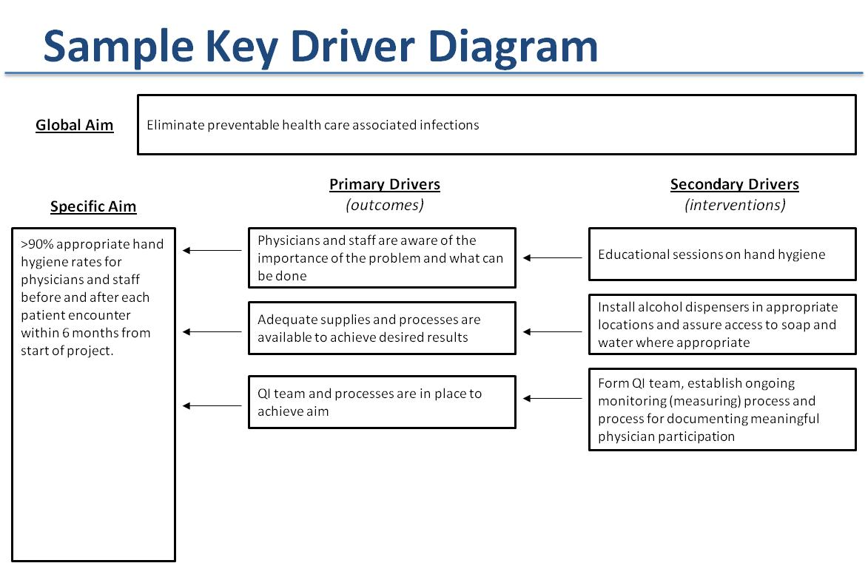
No. This is just a tool and may be modified based on the nature of your MOC project and/or discussions in your QI team. How does this relate to measures?
Primary drivers are usually outcome measures and secondary drivers are usually process measures, though this is not always the case.

What is the benefit of a key driver diagram?
It quickly identifies the important aspects of your QI effort by explicitly defining the logic behind your improvement effort. In identifying the aim, you must identify what you want to change or improve (primary drivers) and how you will improve (secondary drivers or interventions). The diagram, when read right to left indicates that if you perform the secondary drivers (interventions) then the primary drivers will improve, and the improvement of the primary drivers will satisfy the aim.

Complete the diagram below. Direction of the arrows can be moved.

Global Aim
Click here to enter text.

Primary Drivers Secondary Drivers
Specific Aim (outcomes) (interventions)
Click here to enter text.
Click here to enter text.
Click or tap here to enter text.

Click here to enter text.
Click here to enter text.

Click here to enter text.

Click here to enter text.

Click here to enter text.
Click here to enter text.

Click here to enter text.
Click here to enter text.

Click here to enter text.

Useful Resources (including Learning Tools for Equity-focused Quality Improvement)

AAP Child Health Equity module (Free; https://shop.aap.org/fighting-racism-to-advance-child-health-equity/)

Bringing Equity into Quality Improvement: An Overview and Opportunities Ahead
(https://healthforce.ucsf.edu/sites/healthforce.ucsf.edu/files/publication-pdf/6.1%20Part%201%20_Equity%20into%20QI.pdf)

Health Equity, Diversity & Inclusion Measures for Hospitals and Health System Dashboards (https://www.aha.org/system/files/media/file/2020/12/ifdhe-inclusion-dashboard-FINAL.pdf)

Health Equity Challenges and CMS Resources to Help Address Them (https://www.cms.gov/sites/default/files/2022-03/CMS%20OMH%20Health%20Equity%20Infographic_Remediated.pdf)

Using rising tides to lift all boats: Equity-focused quality improvement as a tool to reduce neonatal health disparities - ScienceDirect (https://www.sciencedirect.com/science/article/abs/pii/S1744165X21000068)

Seattle Children’s Enterprise Analytics – QI Advisor (AdaptX)
Enterprise Analytics: QI Advisor | Seattle Children's (seattlechildrens.org)

