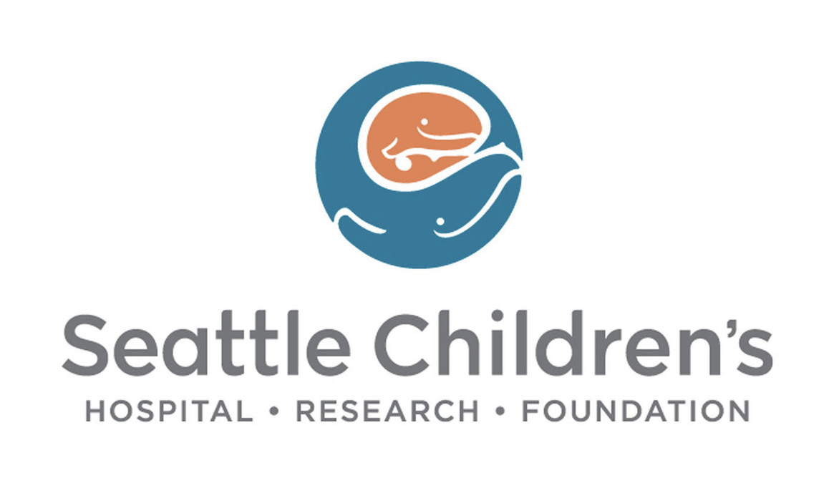
Seattle Children’s Administrative Fellowship Informational Webinar Packet

August 10, 2022 & August 12, 2022
Presented by Taylor Floyd, Jocelyn Rosen, & Tiffany Liu

Please ensure you mute your device upon entering the webinar. This packet can be accessed during and after the Webinar at: (insert link here)
- Agenda
- Fellow Introductions
  - Taylor Floyd - Administrative Fellow (2021-2023)
    - From:
      - Jacksonville, FL
    - Studied:
      - University of Florida – BA, MHA
    - Why SCH:
      - Dedication to EDI and mission
      - Structure of fellowship
        - 2-year cycle
        - Flexibility
      - Fellow visibility
      - Retention of fellows & success within the organization
  - Jocelyn Rosen – Administrative Fellow (2022-2024)
    - From:
      - Minneapolis, MN
    - Studied:
      - University of Minnesota – BS
      - University of Iowa – MHA
    - Why SCH:
      - Passion for pediatrics
      - Commitment to mission and culture
      - Dedication to community health
      - Exposure and relationships with senior leadership
      - Fellowship structure & support from previous fellows
  - Tiffany Liu – Administrative Fellow (2022-2024)
    - From:
      - Seattle, WA & Taiwan
    - Studied:
      - University of Washington – Seattle, School of Nursing
    - Why SCH:
      - Former patient and nurse at SCH
      - Commitment to improving health equity, diversity, and inclusion
      - Strong networking opportunities
- Seattle Children’s Overview
  - Founding of Seattle Children’s
    - Children’s was founded in 1907 by Anna Clise after the death of her young son from inflammatory rheumatism.
    - Clise established the first facility in the Pacific Northwest to treat these children.
    - Clise’s original vision
      - To care for children regardless of race, religion, gender, or a family’s ability to pay – still guides Seattle Children’s today.
- One team. One mission. One vision
  - Our mission
    - We provide hope, care and cures to help every child live the healthiest and most fulfilling life possible.
  - Our Vision
    - Our founding promise to the community is as valid today as it was over a century ago. We will care for all children in our region, regardless of their family’s ability to pay.
  - Our Values
    - 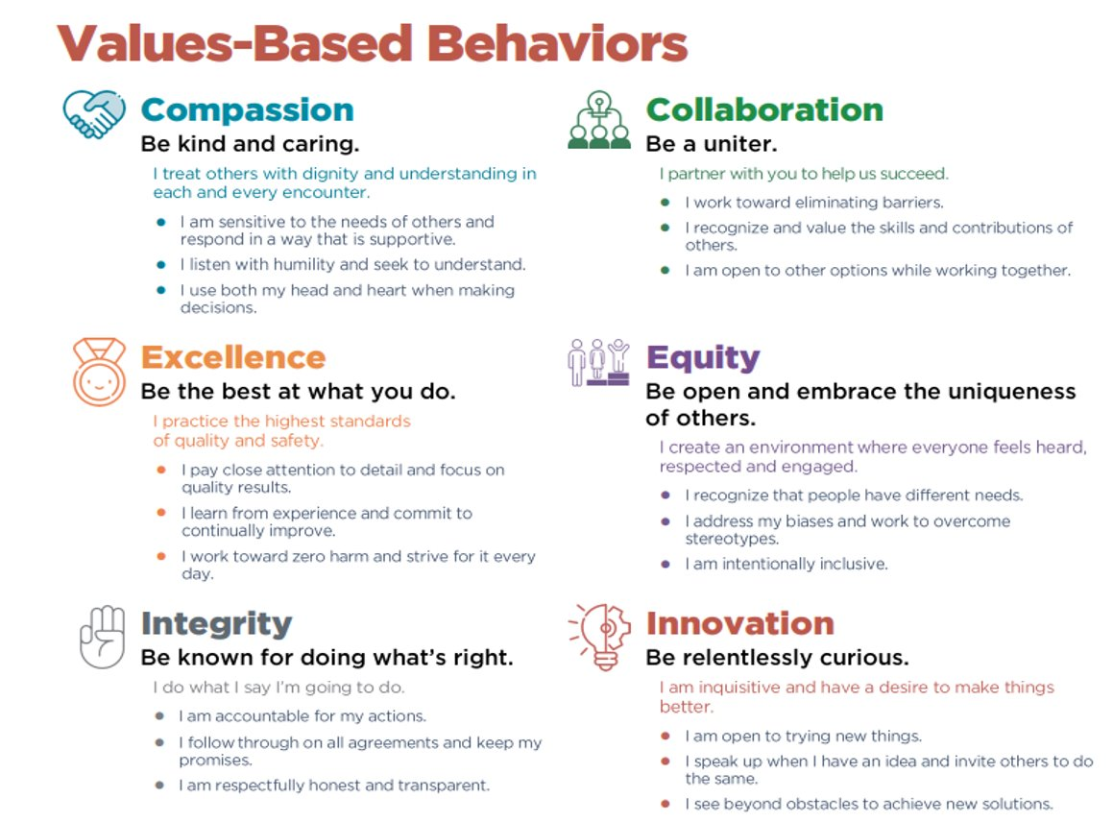
- Seattle Children’s Enterprise
  - Seattle Children’s Hospital (Care)
    - Specializes in meeting the unique physical, emotional, and developmental needs of children from infancy though young adulthood – regardless of a family’s ability to pay.
  - Seattle Children’s Research Institute (Cure)
    - Internationally recognized for being at the forefront of pediatric medical research, the institute consists of nine major centers.
  - Seattle Children’s Hospital and Research Foundation (Hope)
    - Plays a vital role in creating better futures for our patients. Through the thousands of donors and guild members, their support ultimately makes it possible for our care and research teams to come together.
- Introduction to Preceptor
  - Russ Williams, MHA – SVP of Strategy, Capital, and Regional Services
    - Where were you a fellow?
      - Fairview Health Services (now M Health) in Minneapolis, MN
    - How did a fellowship help your career trajectory?
      - It gave me great exposure to executive level leaders to learn from, along with a great “system” perspective of healthcare
    - In your opinion, what makes SCH’s Fellowship unique?
      - Truly free-standing regional children’s health system in one of the most beautiful places in the country. A broad chance to experience hospital, ambulatory, research, and system operations
    - Any words of advice or encouragement for prospective fellows?
      - You will have access to people in things as a fellow that you may not have access to for MANY years after, so make the most of it
- Fellowship Application Process
  - Fellowship Overview
    - The Seattle Children’s Administrative Fellowship is tailored to the fellow’s interests, as well as organizational incentives. As a community that welcomes diverse experiences, backgrounds and thoughts, fellows gain valuable mentorship and professional development opportunities throughout the organization.
- Fellowship Structure
  - 1st year – Broad Exposure to Foundational Concepts
    - Trainings
    - Informational Interviews/Shadowing/Rounding
    - Meeting attendance across the enterprise
    - Project ownership
  - 2nd year – Focused Experience in Selected Area
    - Placed in a managerial role in a division/department
    - Direct Reports
    - Lead division-wide initiatives
    - Lead fellow recruitment, active role in selection process
- Past Fellow Project Examples
  - Developing program to provide nutritional support for breastfeeding mothers
  - Establishing “Great Catch” program to recognize those who catch safety concerns within the organization
  - Developed the process and logistics for transitioning patient and provider populations to SCH
  - Managed first inpatient value stream project aimed at reducing LOS and increasing throughput
- Applicant Qualifications and Materials
  - Qualifications
    - MBA, MHA, MHSA, MPA, MPH, MSN, MHI, or other closely related programs from an accredited program (one position offered)
  - Application Materials
    - Current resume
    - Three letters of recommendation
    - Official or Unofficial transcript of completed graduate school courses
    - Narrative statement (less than 500 words)
    - A short essay (less than 250 words)
  - Please submit all application materials in one PDF document with your name, email, and phone number in the header of the first page and complete the online job application
  - The application deadline is Friday, September 9th, 2022
- Application Timeline
  - September 9th – Application due
  - September 15*16th – Notification of advancement to phone interviews
  - September 26-30th – interviews conducted
  - October 3-4th – notification of advancement to final rounds
  - October 13-14th – Final rounds
  - October 17th – Offer extended
- Appendix
  - Recent Fellows Post Fellowship Trajectory
    - 2016-2018
      - Kelsey Hyatt, MHA l Tulane University, School of Public Health and Tropical Medicine
        - Manager, Administrative Services, North Sound Clinic, Seattle Children’s
      - Snigdha Paruchuri, MHSA l University of Michigan, School of Public health
        - Executive Project manager, Office of the CEO, Seattle Children’s
    - 2017-2019
      - Scotty Sonntag, LICSW, MPA, MHA l University of Utah
        - Manager, Business and Operations Manager, Emergency Services and Urgent Care, Seattle Children’s
    - 2018-2020
      - Keahi Higa, MHA, MPH l University of Utah
        - Business Operations Manager, Imaging Services, Seattle Children’s
      - Melvin Smith, MPH l Brown University
        - Supervisor, Desktop Support Team, Seattle Children’s
    - 2020-2022
      - Makenna Dewell, MHA l University of Washington
        - Patient Access Manager, Cancer & Blood Disorder Center

