**Seattle Children’s Administrative Fellowship Informational Webinar Packet**

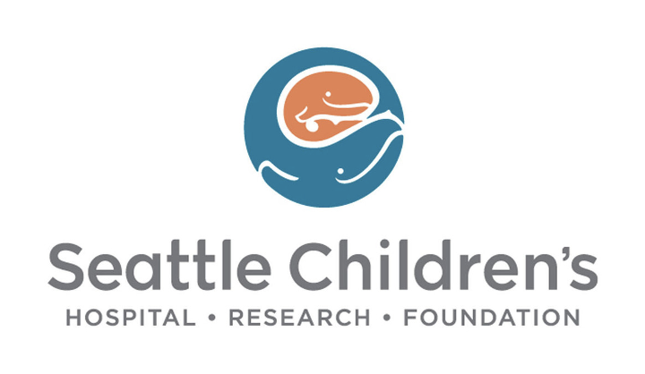

**July 15, 2025 & August 20, 2025**

**Presented by Cherika Urquhart & Kim -Quyen Nguyen**

Please ensure you **mute** your device upon entering the webinar. This packet can be accessed during and after the Webinar.

1. **Agenda**
2. **Fellow Introductions**
   1. Cherika Urquhart – Administrative Fellow (2024-2026)
      1. From:
         1. East Hartford, CT
      2. Studied:
         1. Southern Connecticut State University – MBA
      3. Why SCH:
         1. Passion for Diversity, Equity, & Inclusion
         2. Commitment to mission, vision, & values
         3. Exposure and relationships with senior leadership
         4. Fellowship structure & support from previous fellows
   2. Kim**-**Quyen Nguyen – Administrative Fellow (2025-2026)
3. **Seattle Children’s Overview**
   1. Founding of Seattle Children’s
      1. Children’s was founded in 1907 by Anna Clise after the death of her young son from inflammatory rheumatism.
      2. Clise established the first facility in the Pacific Northwest to treat these children.
      3. Clise’s original vision
         1. To care for children regardless of race, religion, gender, or a family’s ability to pay – still guides Seattle Children’s today.
4. **One team. One mission. One vision**
   1. **Our mission**
      1. We provide hope, care and cures to help every child live the healthiest and most fulfilling life possible.
   2. **Our Vision**
      1. Our founding promise to the community is as valid today as it was over a century ago. *We will care for all children in our region, regardless of their family’s ability to pay.*
   3. **Our Values**
      1. Compassion
      2. Excellence
      3. Integrity
      4. Collaboration
      5. Equity
      6. Innovation
5. **Seattle Children’s Enterprise**
   1. **Seattle Children’s Hospital (Care)**
      1. Specializes in meeting the unique physical, emotional, and developmental needs of children from infancy though young adulthood – regardless of a family’s ability to pay.
   2. **Seattle Children’s Research Institute (Cure)**
      1. Internationally recognized for being at the forefront of pediatric medical research, the institute consists of nine major centers.
   3. **Seattle Children’s Hospital and Research Foundation (Hope)**
      1. Plays a vital role in creating better futures for our patients. Through the thousands of donors and guild members, their support ultimately makes it possible for our care and research teams to come together.
6. **Introduction to Preceptor**
   1. **Myra Gregorian, SVP & Chief People Officer**
      1. **In your opinion, what makes SCH’s Fellowship unique?**
         1. Truly free-standing regional children’s health system in one of the most beautiful places in the country. A broad chance to experience hospital, ambulatory, research, and system operations
      2. **Any words of advice or encouragement for prospective fellows?**
         1. You will have access to people in things as a fellow that you may not have access to for MANY years after, so make the most of it
   2. **Alicia Tieder, VP, Organizational Learning Patient and Family Experience & Health Outcomes**
      1. **In your opinion, what makes SCH’s Fellowship unique?**
         1. The Administrative Fellowship is housed in the People and Culture Division. This creates space and opportunity for the Fellows to advance their careers in administration and operations, while remaining focused on their own development as a strong leader. Leadership qualities are very important, and the goal is to support the growth of future leaders.
      2. **Any words of advice or encouragement for prospective fellows?**
         1. The Administrative Fellowship is housed in the People and Culture Division. This creates space and opportunity for the Fellows to advance their careers in administration and operations, while remaining focused on their own development as a strong leader. Leadership qualities are very important, and the goal is to support the growth of future leaders.
7. **Fellowship Application Process**
   1. **Fellowship Overview**
      1. The Seattle Children’s Administrative Fellowship *is tailored to the fellow’s interests, as well as organizational incentives.* As a community that welcomes diverse experiences, backgrounds and thoughts, fellows gain valuable mentorship and professional development opportunities throughout the organization.
8. **Fellowship Structure**
   1. **Broad Exposure and Learning (Months 1-6):**
      1. Participate in trainings, informational interviews, shadowing, and rounding
      2. Attend meetings across the organization to gain a comprehensive understanding of operations
      3. Take ownership of projects to develop foundational skills
   2. **Focused Experience (Months 7-12):**
      1. Deploy to a specific area within the hospital, aligning with organizational needs and personal interests
      2. Engage in in-depth learning and development opportunities
      3. Lead initiatives and observe their progress from start to finish
9. **Past Fellow Project Examples**
   1. Developing program to provide nutritional support for breastfeeding mothers
   2. Establishing “Great Catch” program to recognize those who catch safety concerns within the organization
   3. Developed the process and logistics for transitioning patient and provider populations to SCH
   4. Managed first inpatient value stream project aimed at reducing LOS and increasing throughput
10. **Applicant Qualifications and Materials**
    1. **Qualifications**
       1. MBA, MHA, MHSA, MPA, MPH, MSN, MHI, or other closely related programs from an accredited program (one position offered)
    2. **Application Materials**
       1. Current resume
       2. Three letters of recommendation
       3. Official or Unofficial transcript of completed undergraduate and graduate school courses
       4. Narrative statement (less than 500 words)
       5. A short essay (less than 250 words)
    3. Please submit all application materials in **one PDF document** with your name, email, and phone number in the header of the first page and complete the online job application
    4. **The application deadline is Friday, August 29th, 2025**
11. **Application Timeline**
    1. August 29th – Application due
    2. September 5th – Notification of advancement to phone interviews
    3. September 9 - 11th – Interviews conducted
    4. September 12th – Notification of advancement to final rounds
    5. September 22nd - 24th – Final rounds
    6. September 26th – Offer extended
12. **Appendix**
    1. **Recent Fellows Post Fellowship Trajectory**
       1. **2023-2025**
          1. **Stephanie Arellano, CTRS, MHA |** Western Carolina University
       2. **2022-2024**
          1. **Jocelyn Rosen, MHA |** University of Iowa
       3. **2021-2023**
          1. **Taylor Floyd, MHA |** University of Florida
       4. **2020-2022**
          1. **Makenna Sewell, MHA |** University of Washington
       5. **2018-2020**
          1. **Keahi Higa, MHA, MPH** | University of Utah
          2. **Melvin Smith, MPH** | Brown University
       6. **2017-2019**
          1. **Scotty Sonntag, LICSW, MPA, MHA** | University of Utah
       7. **2016-2018**
          1. **Kelsey Hyatt, MHA |** Tulane University, School of Public Health and Tropical Medicine
          2. **Snigdha Paruchuri, MHSA** | University of Michigan, School of Public Health