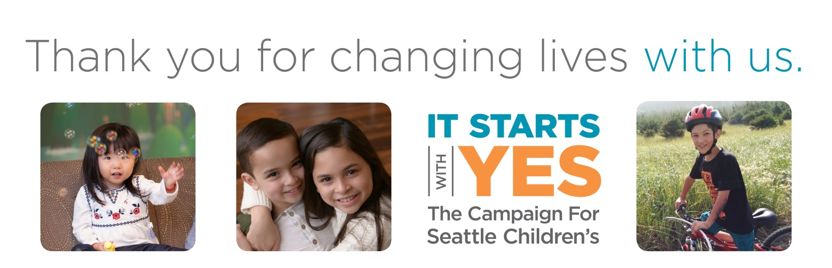
Date
First Name, Last Name
Address
City, State, Zip

Dear First Name,

Thank you for your support of my event, [EVENT NAME], on [DATE] at [LOCATION]. With your help, we were able to raise $[EVENT TOTAL] to support Seattle Children’s [INSERT FUND HERE]!
The goal of Seattle Children’s is to be the best, and we couldn’t do it without the generous support of our community. Your efforts help us provide outstanding patient care, support research into groundbreaking treatments and ensure no child who needs us is ever turned away.

Your generosity has helped make Seattle Children’s goal of hope, cares, and cures a reality for children in your community and around the world. Thank you again for your support.

I hope to see you next year!

Sincerely,

Your Name

